

|  |  |  |  |
| --- | --- | --- | --- |
| **Project Name** | Illusive Fitness | | |
| **Project Team** | Illusive | **Module:** | Project Management |
| **Team Member #1** | Patrick Murray – G00344530 | | |
| **Team Member #2** | Cory O’Donoghue - | | |
| **Team Member #3** | Kealan O’Callaghan - | | |
| **Team Member #4** | Kacper Grzenda - | | |
| **Team Member #5** | Oskar Grzenda - | | |
| **Assessment Title** | **Final Report** | **Submitted to:** | Joseph Corr |
| **Date** | 24/03/2020 | | |

Table of Contents

Introduction 2

Assignment 1 3

Assignment 2 5

Assignment 3 14

Assignment 5-B 16

Assignment 5-C 22

Summary 29

Conclusion 29

Plagiarism 30

References 31

Appendix 32

## Introduction

## Assignment 1

Introduction

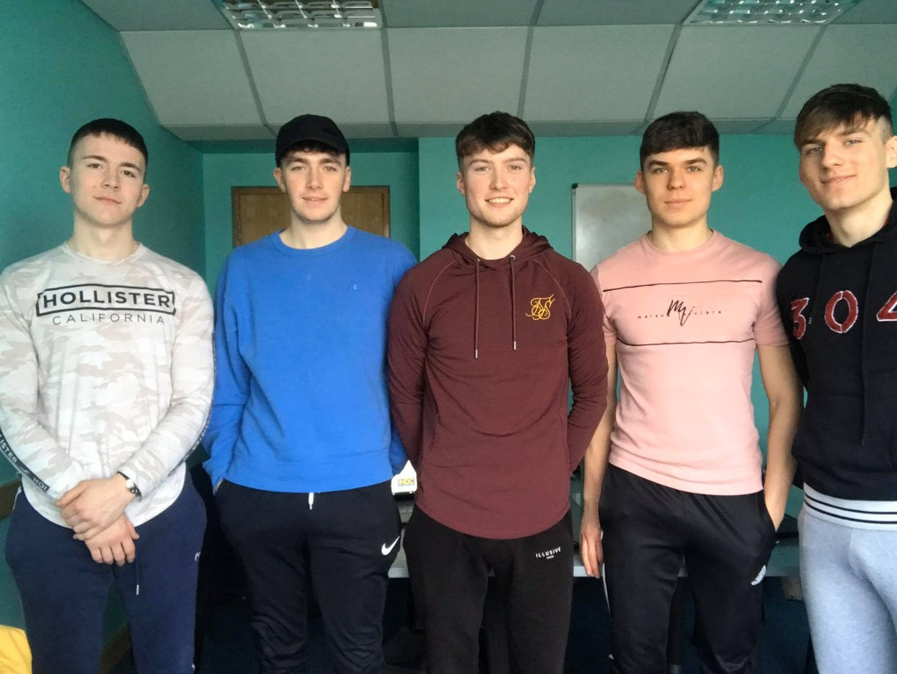

Team Member Names

* Patrick Murray – G00344530
* Cory O Donoghue – G00376678
* Kealan O Callaghan – G00373834
* Kacper Grzenda – G00373427
* Oskar Grzenda – G00373428

Team Roles

* Product Owner – Kealan
* Scrum Master – Cory
* Tester – Oskar
* Engineer 1 – Paddy
* Engineer 2 – Kacper

Hobbies

* Patrick Murray – Soccer
* Cory O Donoghue – Gym
* Kealan O Callaghan – Gaelic
* Kacper Grzenda – Football
* Oskar Grzenda - Gym

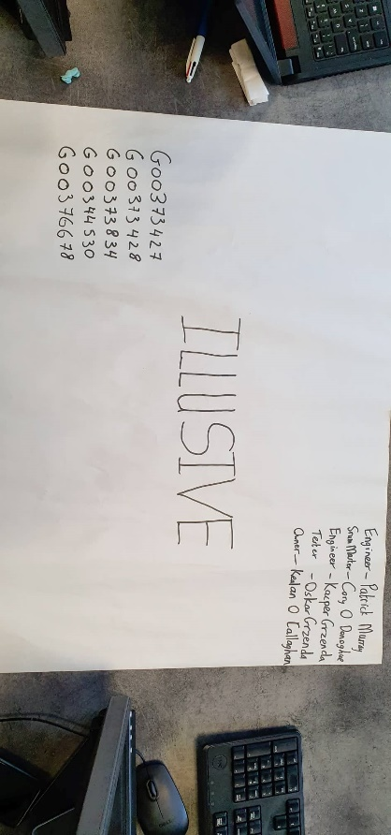Github Project Location

https://github.com/PatrickMurray78/Illusive-Fitness.git

Summary

## Assignment 2

Introduction

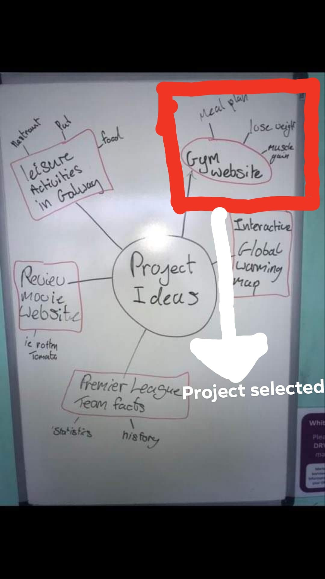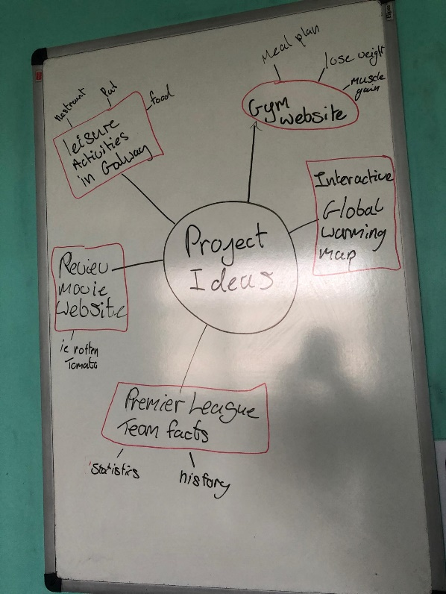

## 

## 

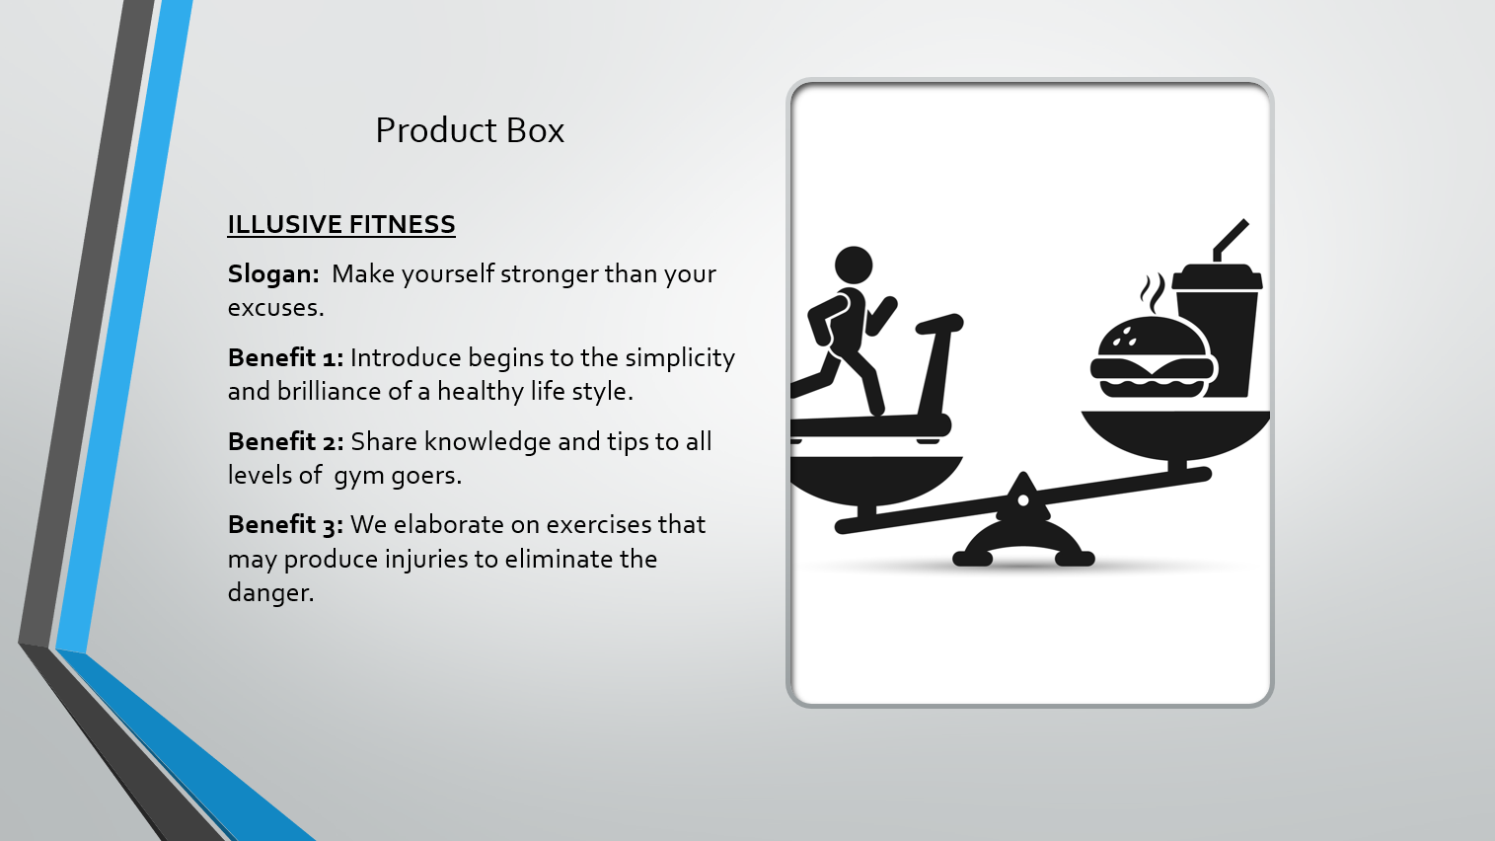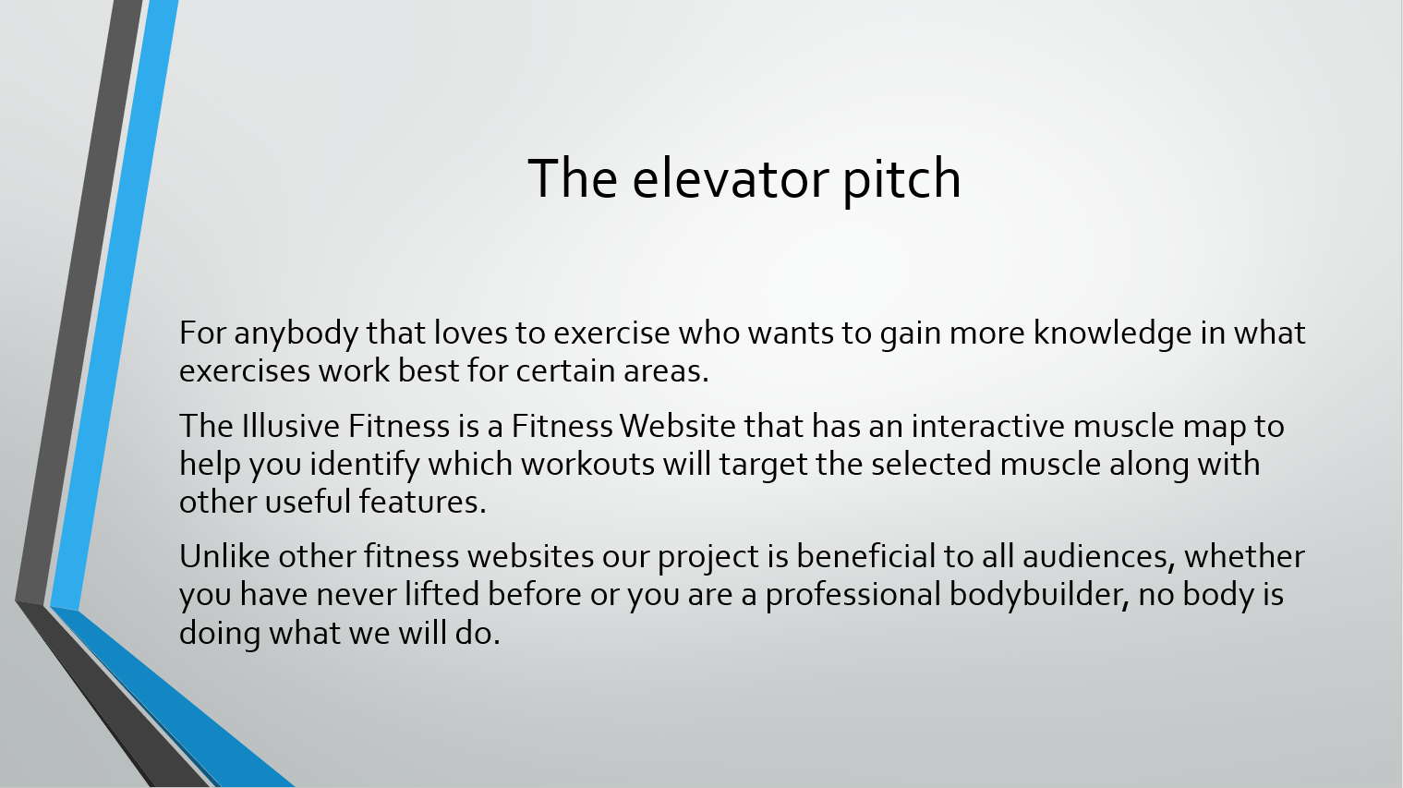

## 

## 

## 

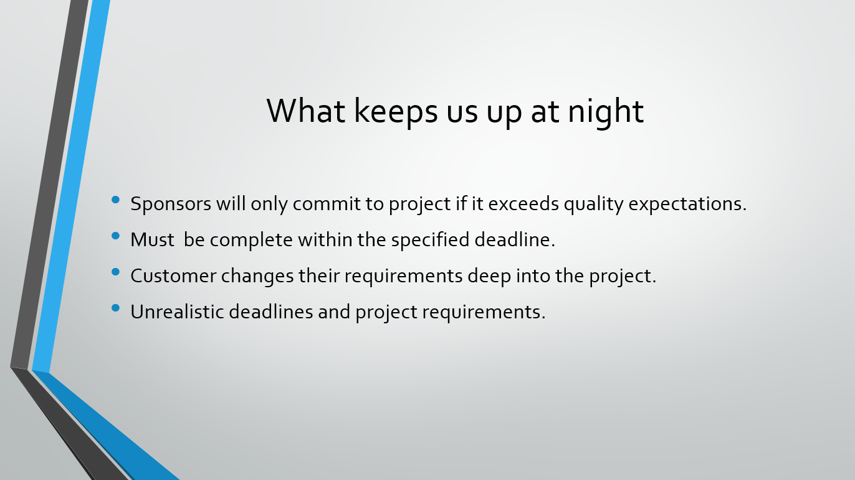

## 

## 

## 

## 

## 

Summary

## Assignment 3

Introduction

# Features / User Story identification and creation and User Story sizing

## Link To Jira

<https://illusivefitness.atlassian.net/secure/RapidBoard.jspa?rapidView=1&projectKey=IL&view=planning.nodetail&selectedIssue=IL-2&issueLimit=100>

# User Story definitions of READY and DONE

**A user story is ready when the product owner (Kealan O Callaghan) can prioritize it and the development team(Kacper Grzenda & Patrick Murray) has enough information to implement it.**

**A user story is done when the product owner (Kealan O Callaghan) accepts the outcome and all criteria are met by the development team (Kacper Grzenda & Patrick Murray). The code has been reviewed and the code is tested by the tester (Oskar Grzenda).**

# Team Working Agreement

## Team Name

Illusive

## Team Mission

To develop a fitness website which follows the guidelines specified by the owner of the company.

The owner of the company is Kealan O’Callaghan, he wants a website that can help people find easy meal plans and different type of workouts.

The website must be user friendly and allow people to find exercises for specific muscle groups.

## Roles and Responsibilities

Owner: Kealan O’ Callaghan

Scrum Master: Cory O’ Donoghue

Tester: Oskar Grzenda

Engineer: Patrick Murray

Engineer: Kacper Grzenda

## Tools

Jira

GitHub

## Communication

We need to have weekly stand up meetings in our class on Wednesday and meat at least once before the class to get everything together. Use GitHub to upload our assignments so everyone can see them and add their own points to it.

We all agree to take joint responsibility for the outcome of the project, and we all have to have some participation in this project.

# Submission Summary

Our teams approach of establishing the projects user stories were to identify our personas. Then for each persona we established the jobs to be done so we could identify, describe, and size features of each user story.

Our team working agreement was easily met. We all sat and allocated a team member a certain role based on our skill set, knowledge and previous experience relating to project management. Patrick and Kacper were elected as developers because of their programming skills, Oskar was appointed as a tester because of his programming skills, Kealan was put as project manager due to his past projects he lead and Cory was made scrum master as he has previously studied this SDLC.

We sized our user stories by every member of the project anonymously writing down a number (1, 3, 5, or greater) estimating how long a user story will take to develop (1 being not long and 5 being a long time). We than showed each other our estimations we spoke about why we decided with that number. We than got the average of each user story sizing and wrote it in Jira.

Summary

## Assignment 5-B

Introduction

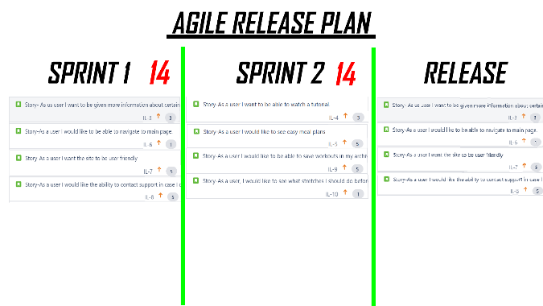**Snapshots of sprint progress**

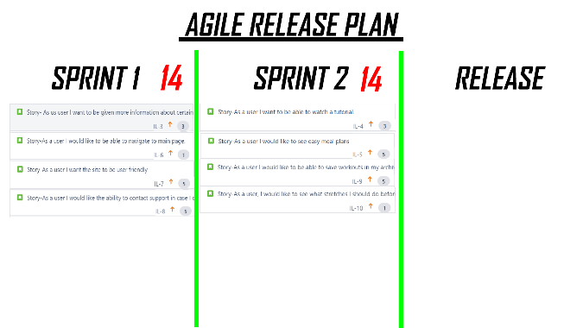

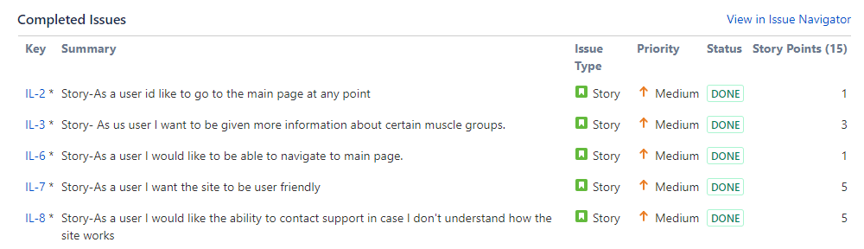

**Burndown chart progress**

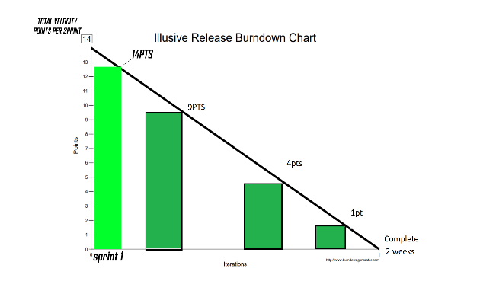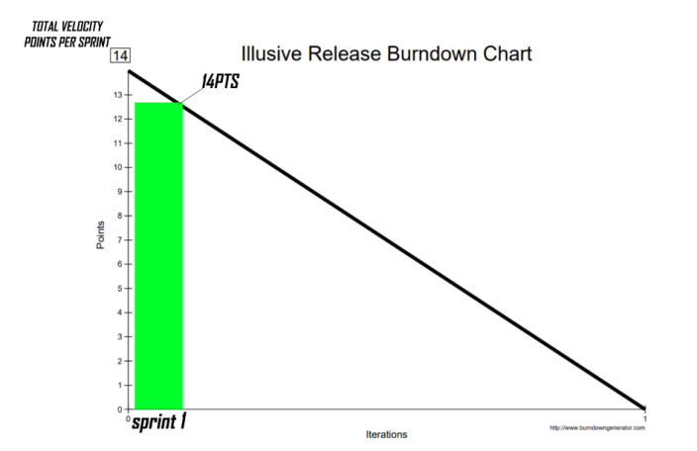

**Issues discussed in stand-ups**

* More involvement from PO regarding user stories
* More 3 CCC’s

**Sprint refinement meeting**

* We held a sprint refinement meeting last Thursday the 27th Feb to discuss if the 1st sprint was completed successfully in regards to the user stories.
* Our PO told us the new user stories he wanted for the next sprint as we prepared for sprint 2.

**Story testing**

* Story testing was very easy to do during our sprint refinement meeting on Thursday as our PO was present and was able to look through the website to see if it was adequate, which it was.

**Code testing**

* An example of the code pulled from github that one of the coders put up for us to test and ensure as a group that it was abiding by the user stories.

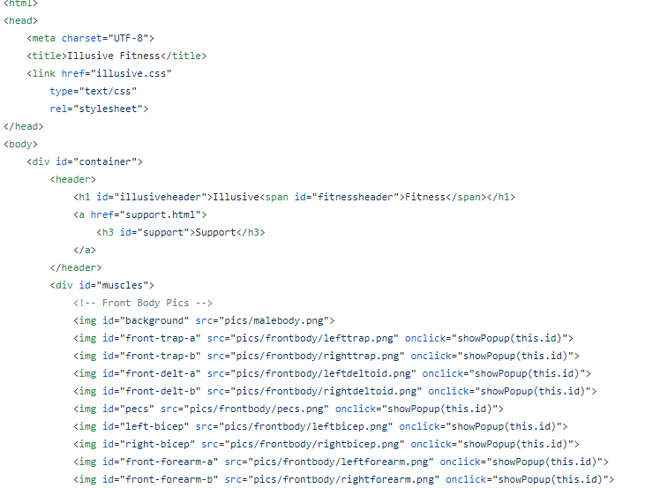

**Sprint 1 user stories status**



**DONE**

**DONE**

**DONE**

**DONE**

**DONE**

* All of the original user stories planned for sprint one were tested and completed.
* The product owner reviewed each of the stories alongside the test website and was satisfied with the results.

**List of user story tasks**

* **Story - IL2 – as a user id like to go to the main page at any point**

1. Completed
2. Owner – Kacper Grzenda

* **Story - IL3 – as a user I want to be given more info on different muscle groups**

1. Completed
2. Owner – Corey O’Donoghue

* **Story - IL7 – As a user i want the site to be user friendly**

1. Completed
2. Owner – Patrick murray

* **As the user I want the ability to be able to contact customer support**

1. Completed
2. Owner – Patrick murray

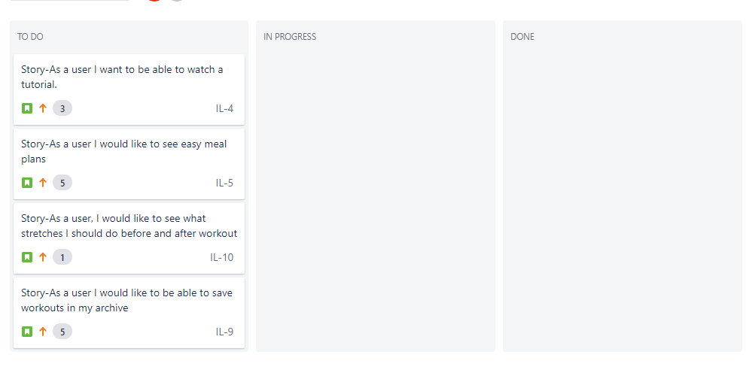

This is our new agile board with 4 new user stories that have been ordered by importance product owner.

**At the End of Sprint 1**

**Story Test plans**

We tested the code by following the tests that were set for each user stories and every user story was reviewed and checked by the tester. When every line of code was tested by the product owner reviewed the finished working user stories and decided if they were acceptable or not.

**Code baseline before sprint begins and after the sprint has finished**

Our website is written in HTML we had no code until the developers started looking at the scrum board and picking out user stories. Once the developers got the user stories they could begin coding and follow the user story directions.

**Show evidence of code and artefact reviews by the team members**

Here is a screenshot of our GitHub where we can all access the code.

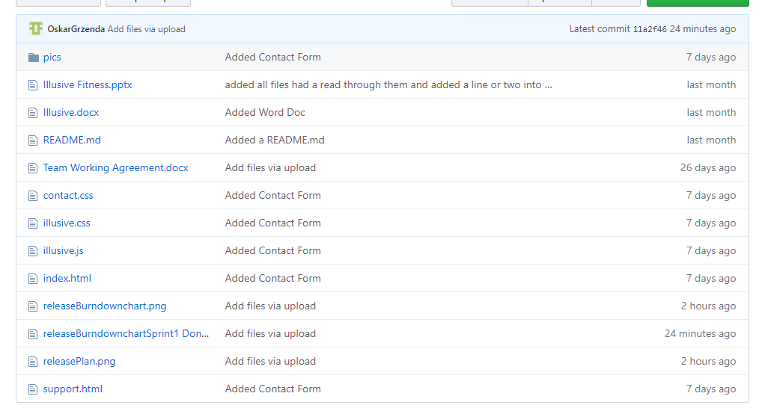

**Updated release plan and release burndown chart after end of sprint 1**

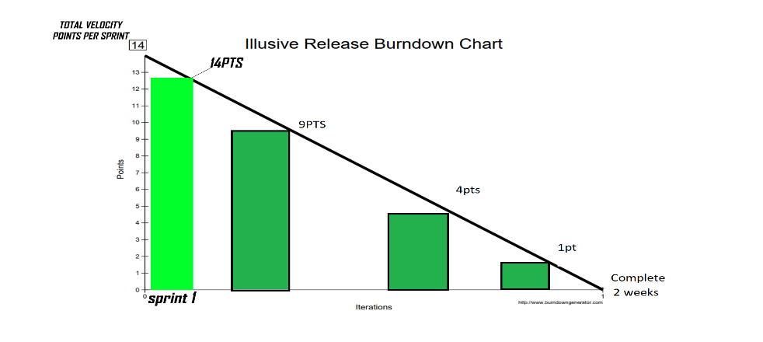

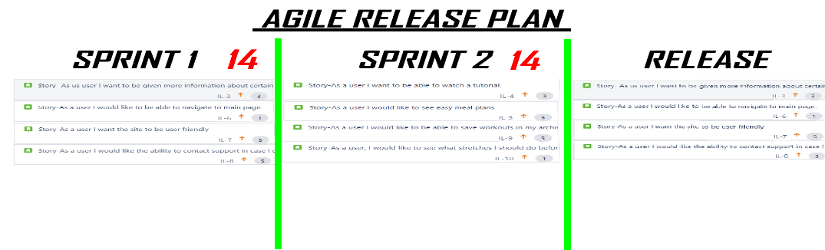

**Sprint 2 Planning**

This is the new release burndown chart for sprint 2

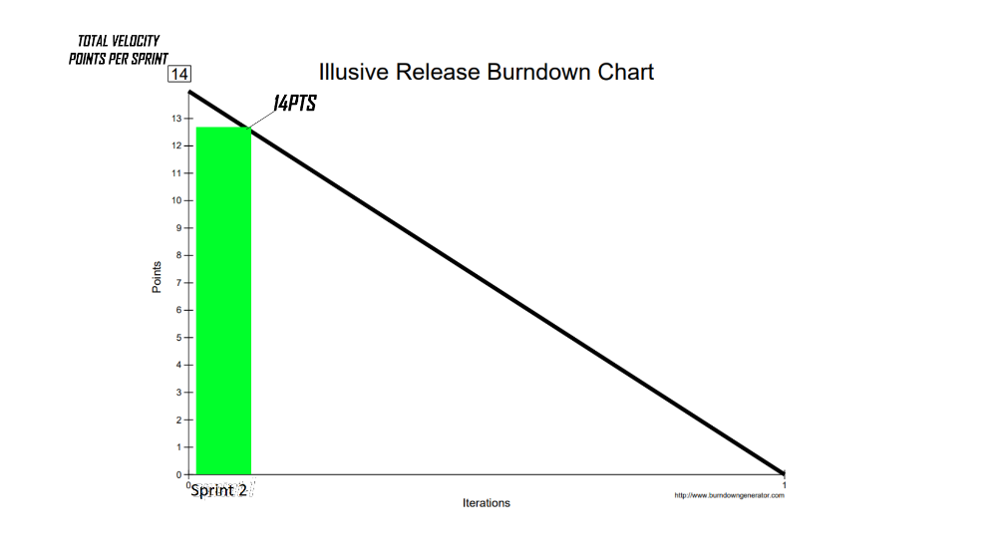

This is the upadted release plan after sprint 1 has been completed



**The revised team velocity and how it was calculated**

We calculated each velocity point for each user story by meeting as a team and each member wrote what amount of velocity points each user story should have and we put them all together and averaged them out. Below you can see our sprint 2 scrum board and each user story has the velocity points beside them adding up to a total of 14.

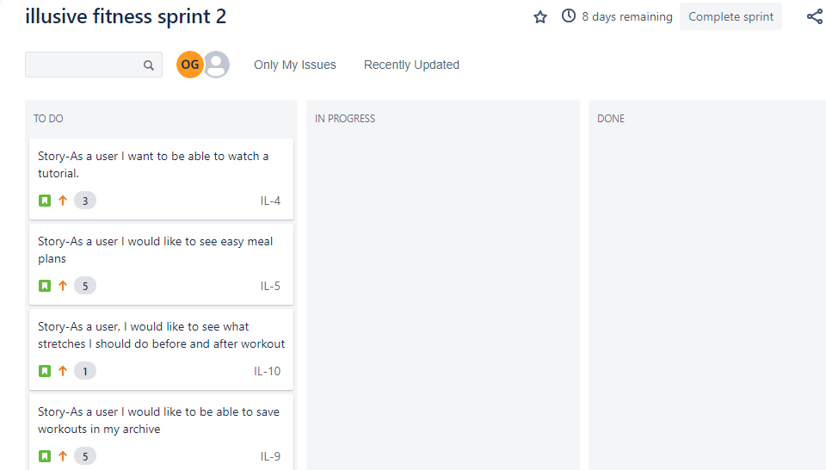

**Brought forward corrective stories from the retrospective at the end of sprint 1**

After sprint 1 we did not have to bring any corrective stories the development team got all the code done in time and fit all the user stories into the project in time.

**Before Sprint 2 Begins**

Before sprint 2 begins we have had meetings in class and an hour before class we have a big A3 size sheet stuck up on the wall which we have many user stories stuck to it and we have just discussed how we will approach sprint 2. We have already completed sprint 1 so we have learned some things already. Sprint 1 went okay we did not have any major problems, and everything was finished on time. So, we are hoping sprint 2 goes the same. We have our sprint 2 set up on Jira also just as Sprint 1 was.

Summary

## Assignment 5-C

Introduction

**Snapshots of sprint progress**

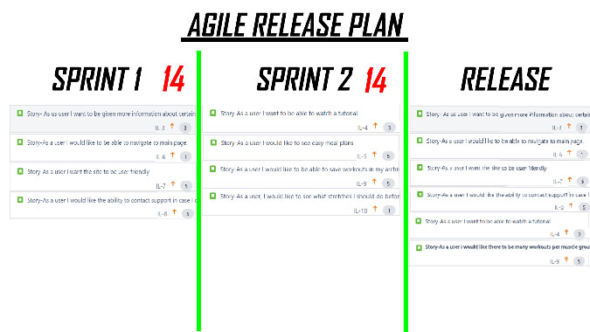****

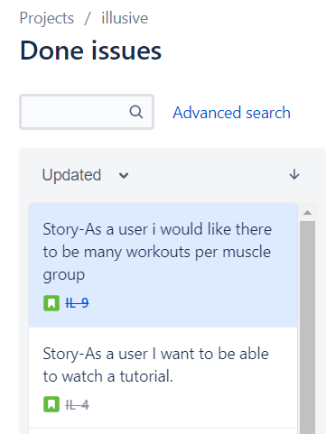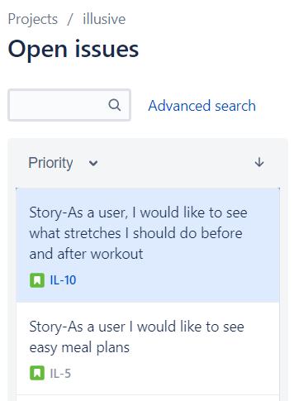

**Burndown chart at beginning of sprint:**

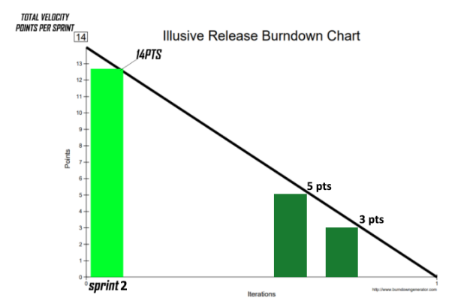

**Daily Stand ups-** Software to be used for acceptance testing.

-Issues/progress/next steps regarding user stories in phase 2.

-Does PO want to make any changes.

-Have we saved protype of code from phase 1 in case of bugs in new code.

**Changes During Sprint:**

We were unable to complete every user story. This was due to technical errors & the time frame we had.



**Issues in Stand-up:**

* We faced technical problems revolving around the code for website encountering bugs etc.
* These bugs effected are time frame that we allocated to each user story.
* Difficult to test code on software ‘J unit’ as language we used was HTML and JavaScript.
* Instead we had to do a screencast showing the functionality of the website.

**Evidence of Sprint refinement meeting:** After colleges were cancelled for two weeks, we used Facebook messenger as our platform of communication where we would conduct our daily stand-ups, ask questions, ask her help etc.

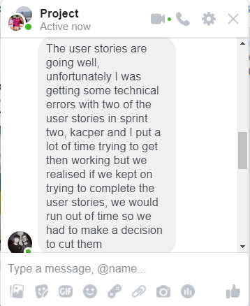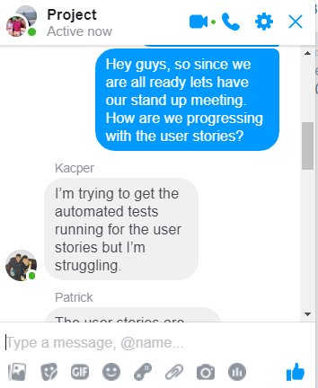

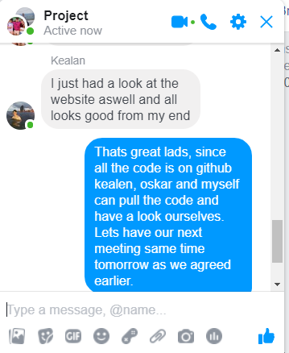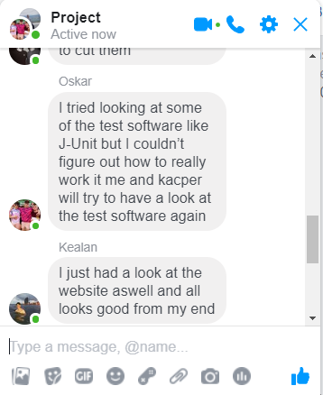

**Evidence of testing:**

|  |  |  |  |
| --- | --- | --- | --- |
| **Test** | **Test Plan** | **Test Result** | **Pass/Fail** |
| Can user click body part? | Select body part using mouse. | Body part successfully selected and link to workout shown | Pass |
| Is the site user friendly? | Can user navigate through page easily? | No confusion shown while browsing webpage. | Pass |
| Can user watch a tutorial? | Select body part and choose tutorial link? | Link brings you to tutorial. | Pass |
| Can user view meal plans? | Select body part and see a meal plan? | No option for meal plan | Fail |

**End of Sprint 2:**

**Framework testing:** The Product Owner decided that the story to be taken out of the backlog and be replaced by the spike was ‘different type of stretches’ issue.



**Outputs of the testing:** We attempted to carry out the acceptance testing using the software J unit but it proved to be very difficult as we designed the website using HTML and CSS. Therefore the only way we could conduct the test to show the website worked was to make a screen record of the websites functionality.

**Burndown Chart At the end of sprint 2:**

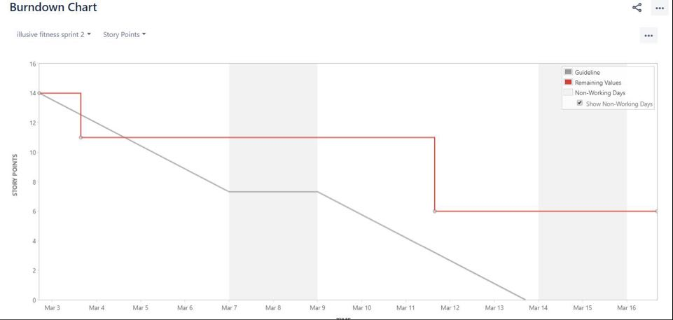

**User stories status: Complete**

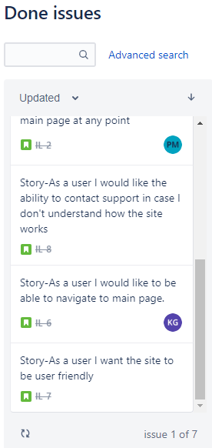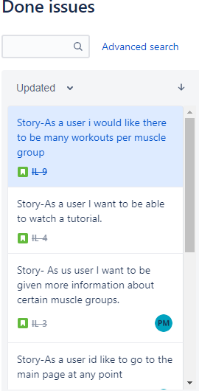

**User stories status: Incomplete**

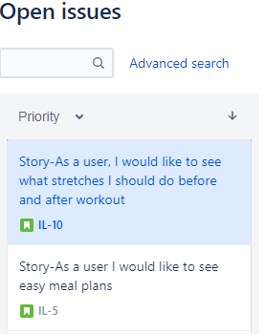

-The Reason this story was rejected was the product owner replaced it with the spike.

-The reason this story was rejected was because there was technical issues which later effected the time frame, therefore it was left.

**Baseline code Sprint 1:** It is difficult to present baseline code as there were hundreds of lines in three separate languages, HTML,CSS,Javascript because we created a website. Below I will attach a snippet of the baseline code but if you wish to see it fully you must go on to Git

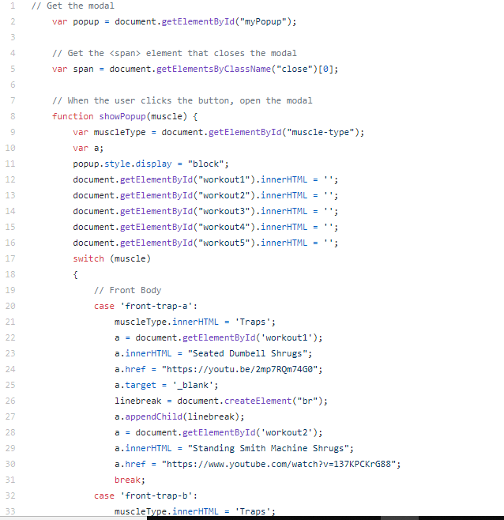

**Baseline code Sprint 2:** Here is a snippet of the baseline code for phase 2 in HTML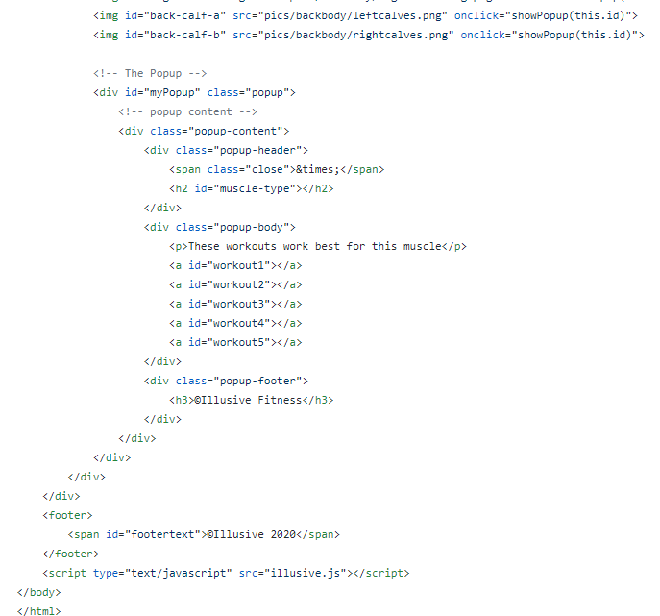.

**Links to documentation:** <https://github.com/PatrickMurray78/Illusive-Fitness/tree/master/docs>

Summary

## Summary

## Conclusion

## Plagiarism

Plagiarism: By submitting the assignment, you are stating that you have read and understood the GMIT plagiarism guidelines. Plagiarism detection software will be used during the assessment of the submissions. The GMIT plagiarism policy can be read at the following web address

<http://www.gmit.ie/sites/default/files/public/directorate/docs/academic-policy-no2.pdf>

Signature : ______________________________ Date: ___________

Signature : ______________________________ Date: ___________

Signature : ______________________________ Date: ___________

Signature : ______________________________ Date: ___________

Signature : ______________________________ Date: ___________

## References

## Appendix

MEMBERS

Kealan O' Callaghan - Owner

Cory O' Donoghue – SCRUM Master

Patrick Murray – Engineer

Kacper Grzenda - Engineer

Oskar Grzenda - Tester



Project Name

ILLUSIVEFitness

Goal

The main goal of this project is to create a website which can help extend the knowledge of its users regarding anything fitness related.

* Improve Experience of beginners in the gym.
* Extend knowledge of intermediate to advanced lifters.
* A Platform where you can discover exercises, meal plans, stretches and much more

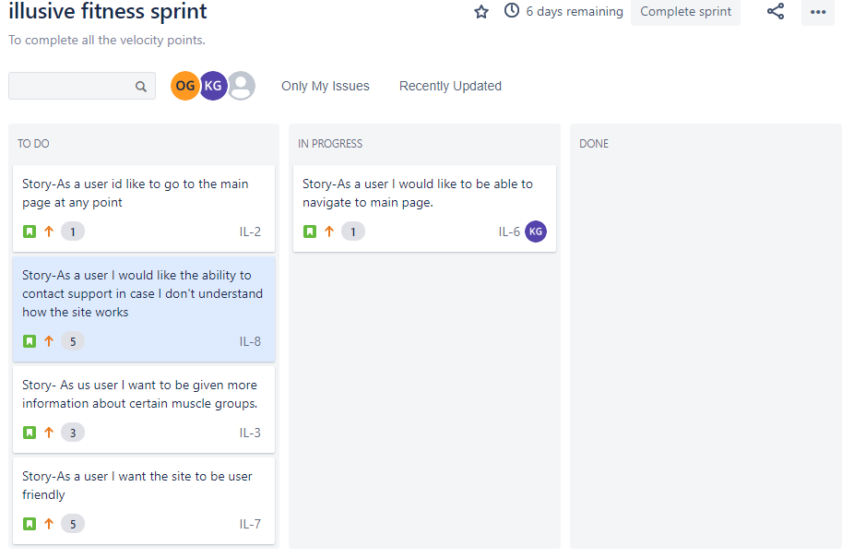

**Sprinting**Assignment 5A

This is our scrum board on Jira we are

using this to pick our user stories. Once we pick one we move it to

"in progress" and then we know who is going to work on

That particular user story. Once they are finished they move the user story to

"done".

28-02-2020

Planning:

* The goals of the week for our team is that our software developers stay on schedule on implementing our user stories.
* Our software tester ensures software is bug free.
* Scrum master holds team meeting to check progress with the team.
* No issues.

Progress:

* Developers have successfully implemented half of the user stories. Stuck to schedule correctly.
* Tester looked thoroughly through code and found no bugs and excellent practice of code.
* No issues to be resolved.

Event details

* Daily stand up meeting held every Friday accompanied by one extra meeting per week organized by the team availability and schedule(normally Wednesday hour before lab)
* Previous brainstorming sessions have been based on ideas for the app and how to implement them. However at the minute we have made all classifications and began implementing therefore have not had a brainstorming meeting this week.

9-03-2020

Planning:

* The goals of the week are to work on sprint 2 and keep on track with the velocity points.
* The team is working on the website.
* Stand up meetings are being used to talk about progress and difficulties going on.
* No issues.

Progress:

* The user stories are being complete, everything looks to be on track for the release.
* Product owner looks to be happy with the website and no problems.
* The team is working together and there is no issues.

Event Details:

* Daily Stand ups are being used to discuss the project and what the team is working on.

16-03-2020

Planning:

* The goal of this week is to keep working on the sprints from home do the there being no college.
* To host a meeting with the product owner to ensure he is happy with the website.
* For the tester to make sure the software has no over looked bugs.
* To have efficient stand up meetings.

Progress:

* The user stories are being completed at a good rate.
* The product owner is satisfied with the product.
* There is no bugs in the code as of this week which is being regularly tested.

Event details:

* We held a good meeting over the weekend to keep up to date with each others progress.
* We held a meeting with the product owner and he is satisfied with the results of the website thus far.